Unreal Game Development Documentation

SIT151 ASSIGNMENT 3

Game Name:

Run! Run! Run!

STUDENT NAME: Hang ZHANG

STUDENT NUMBER: 215404612

CLASS:

Contents

Game Component 1 – NEW ENEMY: 3

DESCRIPTION 3

REASONING 3

BLUEPRINTS AND IMPLEMENTATION 3

Animation Blueprint 3

Blueprint Class 4

Plan for Game Component 2: 6

DESCRIPTION 6

METHOD FOR CONSTRUCTING IN THE UNREAL ENGINE 6

SKETCHES 6

References 8

# Game Component 1 – NEW ENEMY:

## DESCRIPTION

A giant monster tries to attack you if you come face to face with him, once it/them catch you then the game is over. In order to survival, player has to run all the time and use obstacles to gain distance advantage.

The mesh materials are from Infinity Blade: Adversaries in Epic market for free.

## REASONING

The game is all about to evade monsters and escape at a certain point after stealing treasure from them, the giant troll is fulfilling the requirement. It looks necessarily scare to increase tense and has animation included.

In order to make this enemy ‘trying to attack you’, AI and Pawn Sensing are used.

## BLUEPRINTS AND IMPLEMENTATION

### Animation Blueprint

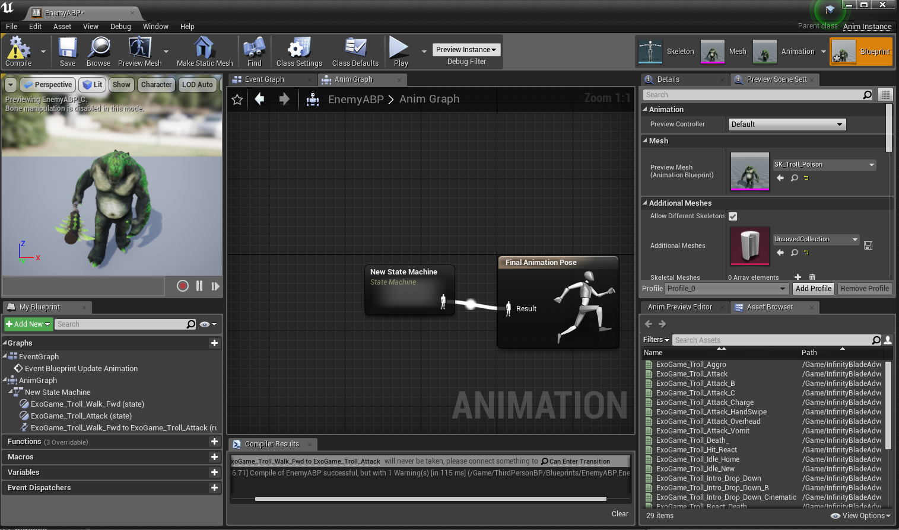

By using state machine to trigger the animation asset.

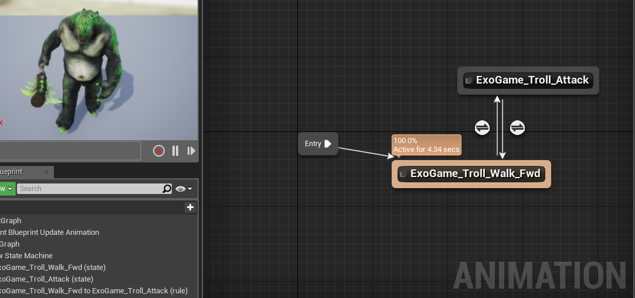

By default, the monster will use ‘ExoGame_Troll_Walk_Fwd’ as initialised animation, if it close enough with player, it will use attack animation instead.

### Blueprint Class

Create an empty blueprint class than fill the skeletal mash and animation class.

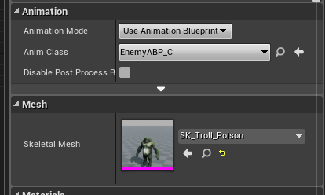

Then make blueprint in event graph.

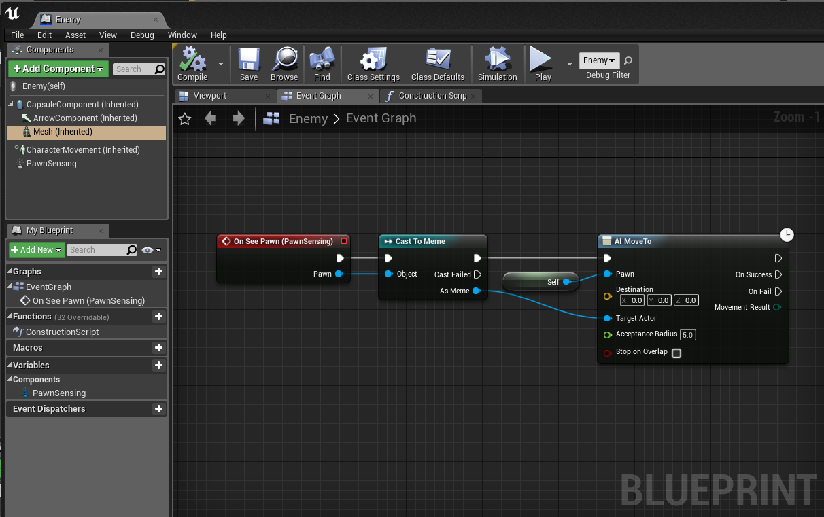

On see pawn will trigger movement when the monster ‘see you’, then use AI to move the position of monster with suitable animation. The PawnSensing component will provide the range of ‘seeing’.

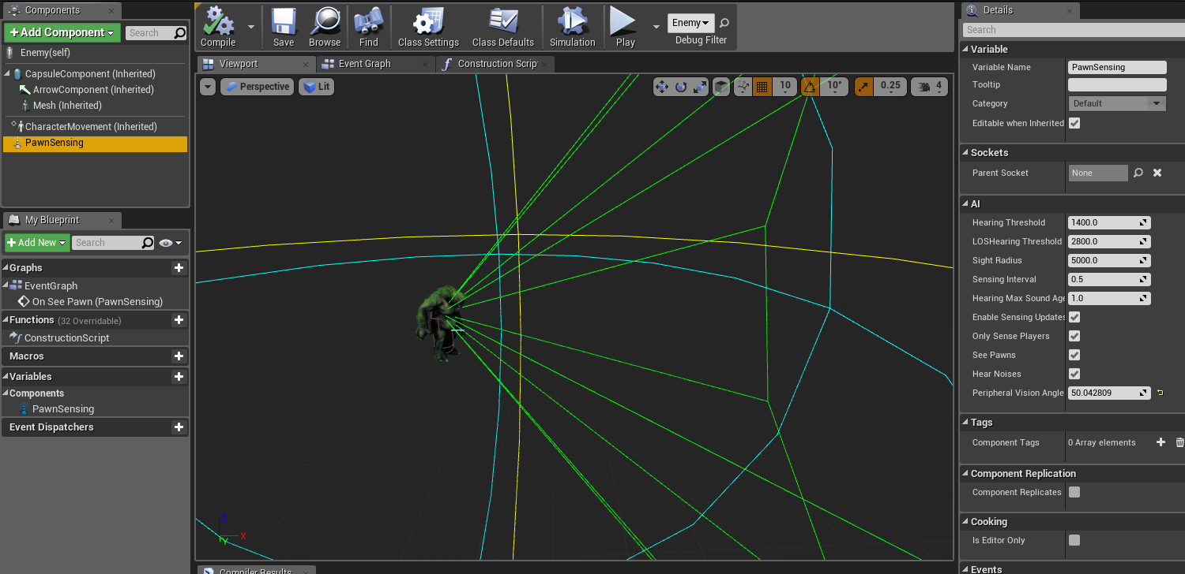

After this, the monster will move towards to player when it see you in range.

## Video address

https://youtu.be/RWRM1x5BN5k

# Plan for Game Component 2:

## DESCRIPTION

VICTORY CONDITION

Currently there is no ending in this game, so a victory condition must be added in to this project, and the enemy number may be adjusted in the final version.

## METHOD FOR CONSTRUCTING IN THE UNREAL ENGINE

For individual unit, the class stay the same, by duplicating current enemy class to make ‘enemy waves’. I can add more unique class to make different enemies.

## SKETCHES

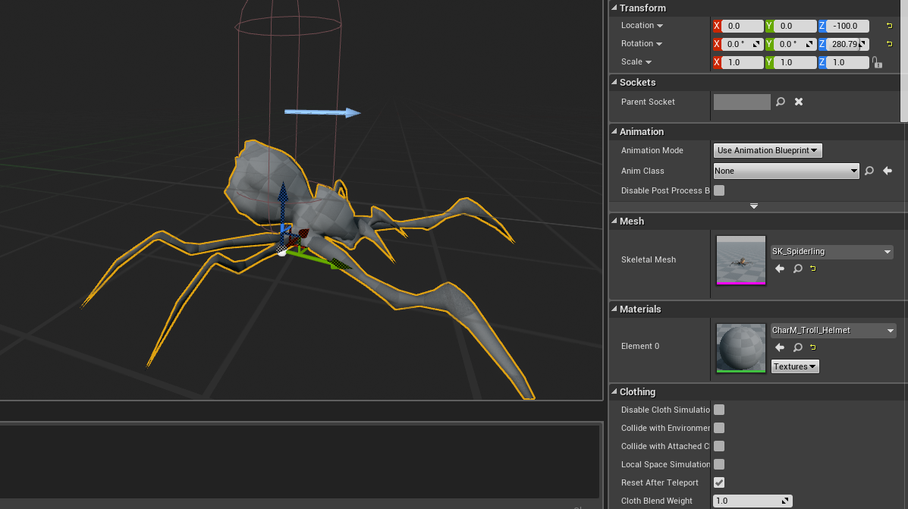

Currently testing another enemy skeletal mesh.

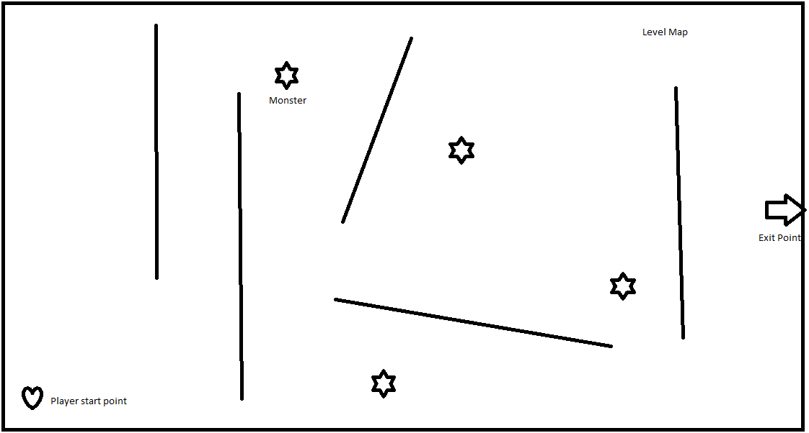

That is the basic concept of one level in this game, player try to survival by escape from exit point, however player have to bypass few monsters within the map.

# References

Games, E. (2015, 9 10). *Epic Games*. Retrieved from Infinity Blade: Adversaries: https://www.unrealengine.com/marketplace/infinity-blade-enemies